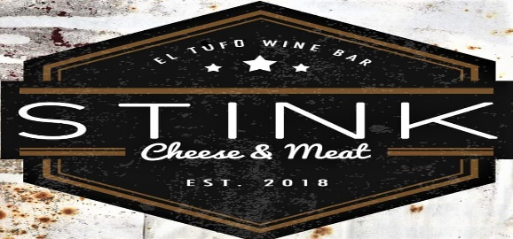

(Top 5 items Served with Fruit or Stink Spuds)

Bread Pudding-Style French Toast $13
Ask you server for the special flavor of the day!

Monte Stinko $11
Ham, turkey, fontina, and sharp cheddar. Grilled panini-style, sprinkled with powdered sugar, served with blackberry jam
Prosciutto Eggs Benedict $15
Slices of prosciutto, topped with poached egg and hollandaise sauce, served over flaky croissant
Crab melt benedict $17
Our famous crab melt, topped with poached eggs and hollandaise
Biscuits & Gravy $13 Stinks’ secret sausage gravy recipe served over Sig Brewing’s famous biscuit
*Molettes $11 Toasted Bolillo bread, housemade refried black beans, melted cheese, pico de gallo *Add fried egg for $2
*Patatas Bravas $13
Fried potatoes, red peppers, onions sautéed with chorizo topped with 2 fried eggs
Spinach Orange Salad $13
Spinach greens, Mandarin oranges and red onion tossed in a sherry wine vinaigrette then topped with a warm pecan encrusted disk of goat cheese
Chocolate balsamic salad $13
Chocolate balsamic vinaigrette-covered greens, with caramelized pecans, seasonal fruit, goat cheese & bacon
3 Cheese $14 or 5 Cheese Plate $18
Assorted international cheeses served with seasonal fruit, candied pecans, and warm sliced baguette
Antipasti $20
Assorted cheese & cured meats, marinated olive mix, 18-year aged balsamic served with warm sliced baguette
Roasted Garlic & Pierre Robert $12
French Triple Crème served with roasted garlic & warm baguette
*May be served raw or undercooked. Consuming raw or undercooked meats, poultry, seafood, shellfish, or eggs may increase your risk of food-borne illness

SIDES
3 goat-cheese Bacon Wrapped Dates $7
1 egg $2
Bread basket $2
house salad $6
Fruit $5
Stink Spuds $5

Stink drinks
*Bottomless bloody mary/mimosa $17

Mimosa Flight $12
3 smaller mimosa servings with juice variety

Spicy bloody mary $10
Green Chile Vodka, House Bloody Mary mix with pickled garnish

Mimosa $8
House bubbles with orange juice

Marionberry mule $9
Wild Roots Marionberry Vodka, fresh lime, ginger beer

Old fashioned $11
Coopers Craft Bourbon, demerara, orange

Irish Coffee $9
Irish Whiskey, Coffee, whipped cream

Purple Reign $11
Empress Gin, cucumber-lime-mint shrub, soda

Wine

House red/white/rosé 6/18
Beronia rosé (spain) 10/30
Black Girl Magic Riesling (CA) 8/24
Beach house chenin blanc (S. Africa) 8/24
Inscription Pinot Noir (OR) 13/39
Pazzo Sangiovese (CA) 12/36

Non-Alcoholic

Coke, D. Coke, Sprite, Ginger Ale, Fanta $1.50
Perrier, Root Beer, Ginger Beer $3.00
Juice – Orange, Cranberry, Pineapple $2.50

*Bottomless will be limited to apparently intoxicated guests

